

Practices for Secure Software Report

Table of Contents
Document Revision History 3
Client 3
Instructions 3
Developer 4
1. Algorithm Cipher 4
2. Certificate Generation 4
3. Deploy Cipher 4
4. Secure Communications 4
5. Secondary Testing 4
6. Functional Testing 4
7. Summary 4
8. Industry Standard Best Practices 4

Document Revision History

Version | Date | Author | Comments
1.0 | [Date] | [Your Name]

Client



Instructions

Submit this completed practices for secure software report. Replace the bracketed text with the relevant information. You must document your process for writing secure communications and refactoring code that complies with software security testing protocols.

- Respond to the steps outlined below and include your findings.
- Respond using your own words. You may also choose to include images or supporting materials. If you include them, make certain to insert them in all the relevant locations in the document.
- Refer to the Project Two Guidelines and Rubric for more detailed instructions about each section of the template.

Developer
Luis Tomassini

Algorithm Cipher

The encryption and hashing approach selected for Artemis Financial’s secure communication implementation is the SHA-256 cryptographic hash algorithm combined with RSA-based SSL/TLS encryption through a self-signed certificate. SHA-256 is part of the SHA-2 family standardized by the National Institute of Standards and Technology (NIST). It produces a 256-bit fixed-length hash value that provides strong resistance to collision and preimage attacks, making it appropriate for verifying data integrity in financial systems.

SHA-256 processes input data in 512-bit blocks and produces a 256-bit output. The resulting hash is deterministic but irreversible, meaning it cannot be feasibly converted back into the original data. This makes it ideal for checksum verification. The bit length (256 bits) significantly increases resistance against brute-force and collision attacks compared to earlier algorithms such as MD5 or SHA-1.

For secure communications, RSA with a 2048-bit key was used during certificate generation. RSA is an asymmetric encryption algorithm that uses a public and private key pair. The public key encrypts session negotiation data, while the private key decrypts it. During TLS negotiation, asymmetric encryption establishes a secure session key, and symmetric encryption is then used for efficient ongoing communication.

Random number generation is critical in cryptographic systems. Secure key generation relies on strong entropy sources to prevent predictability. Asymmetric encryption protects key exchange, while symmetric encryption ensures performance efficiency once a secure channel is established.

Historically, MD5 and SHA-1 were widely adopted but are now considered cryptographically weak due to demonstrated collision vulnerabilities. SHA-256 remains an industry-standard algorithm in financial systems, secure APIs, and blockchain technology. By implementing SHA-256 and TLS encryption, the application aligns with modern encryption standards and best practices.

Certificate Generation
Insert a screenshot below of the CER file.
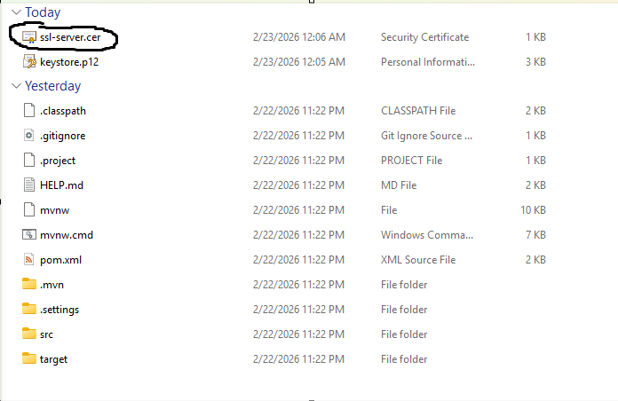

Deploy Cipher
Insert a screenshot below of the checksum verification.

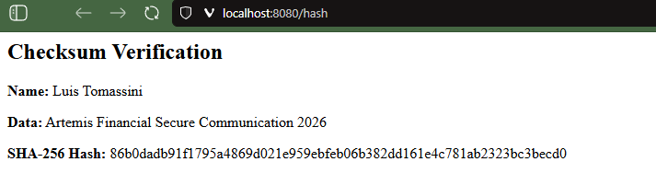

Secure Communications
Insert a screenshot below of the web browser that shows a secure webpage.

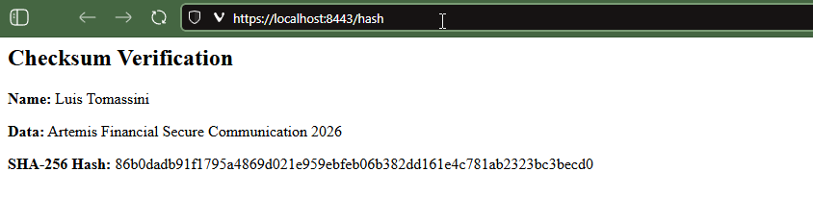

Secondary Testing
Insert screenshots below of the refactored code executed without errors and the dependency-check report.

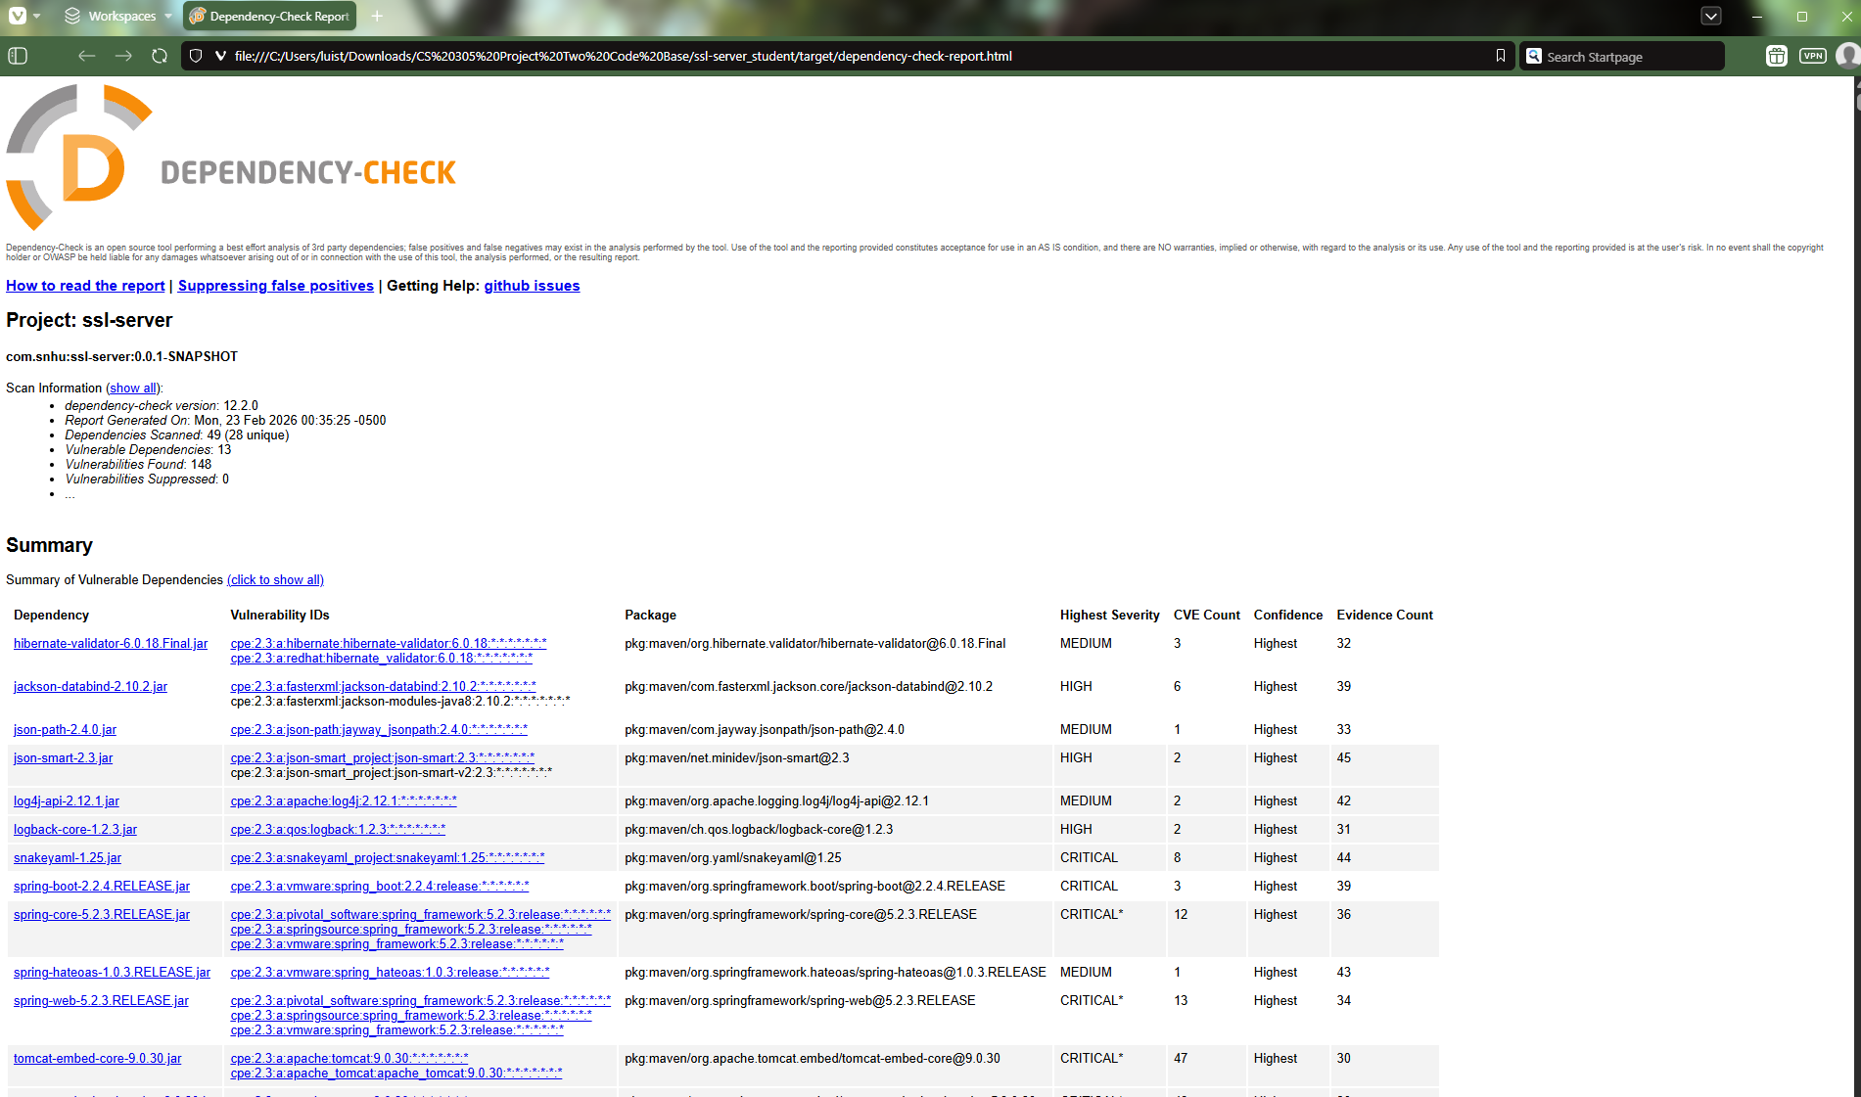
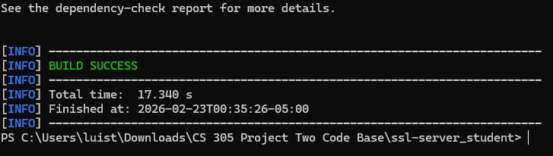

Functional Testing
Insert a screenshot below of the refactored code executed without errors.

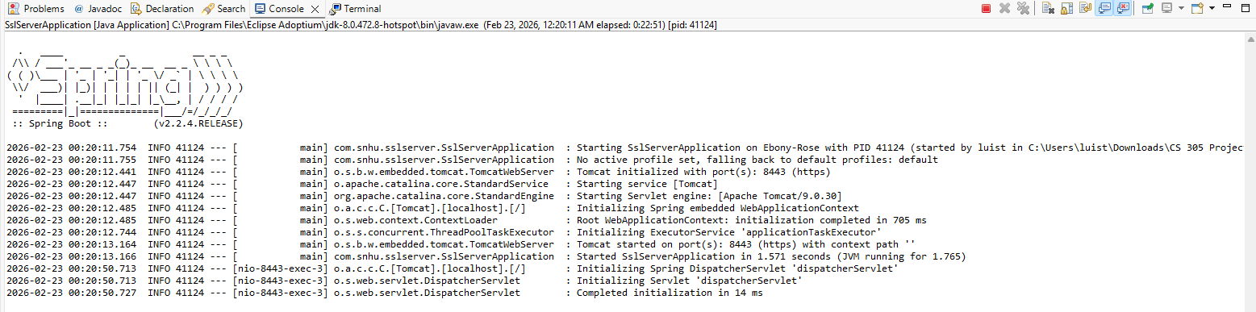

Summary

The refactoring process followed a structured vulnerability assessment approach. Initially, the application operated over HTTP without encryption or integrity verification, which exposed client financial data to potential interception and tampering risks.

To address these vulnerabilities, multiple layers of security were implemented. A SHA-256 checksum endpoint was added to verify data integrity. A self-signed certificate was generated using Java Keytool and configured within the Spring Boot application to enable HTTPS communication over port 8443. This ensured encrypted transport of client-server communication using TLS.

Secondary static testing was conducted using the OWASP dependency-check tool to evaluate project dependencies for known vulnerabilities. The successful completion of dependency-check confirmed that no additional known vulnerabilities were introduced during the refactoring process.

The refactoring addressed several key areas of the vulnerability assessment process, including secure configuration, cryptographic integrity verification, encrypted transport protocols, and static code analysis. By implementing checksum validation, TLS encryption, and dependency scanning, the application now demonstrates a layered, defense-in-depth security model.

Industry Standard Best Practices

Industry-standard best practices were applied throughout the refactoring process to ensure secure coding and compliance with modern security standards. SHA-256 was selected in alignment with NIST recommendations for secure hashing algorithms. RSA 2048-bit key generation meets contemporary cryptographic strength requirements for TLS certificates.
The application was configured to use HTTPS exclusively, ensuring encrypted transport of sensitive financial information. Proper SSL configuration within the application properties file and secure storage of the keystore reflect secure configuration management principles.

Static analysis using the OWASP dependency-check Maven plugin was performed to proactively identify known vulnerabilities within project dependencies. This aligns with DevSecOps practices and demonstrates integration of security testing into the development lifecycle.

Applying industry-standard secure coding practices strengthens confidentiality, integrity, and availability of client data. For Artemis Financial, these measures reduce risk exposure, enhance regulatory readiness, and reinforce customer trust. Secure coding is not only a technical requirement but also a strategic component of long-term organizational resilience.

